How to Book a Conference Room for Your Meeting

Open Microsoft Outlook. On the Home tab, under New Items, choose Meeting.
On the Meeting tab, invite the Required and Optional attendees you wish to invite by typing email addresses, or browsing to their names by clicking the Required or Optional buttons.
Set the Start and End date and time.
Click the Scheduling Assistant tab, and click Add Rooms. Double click the room you’d like to book, and click OK.
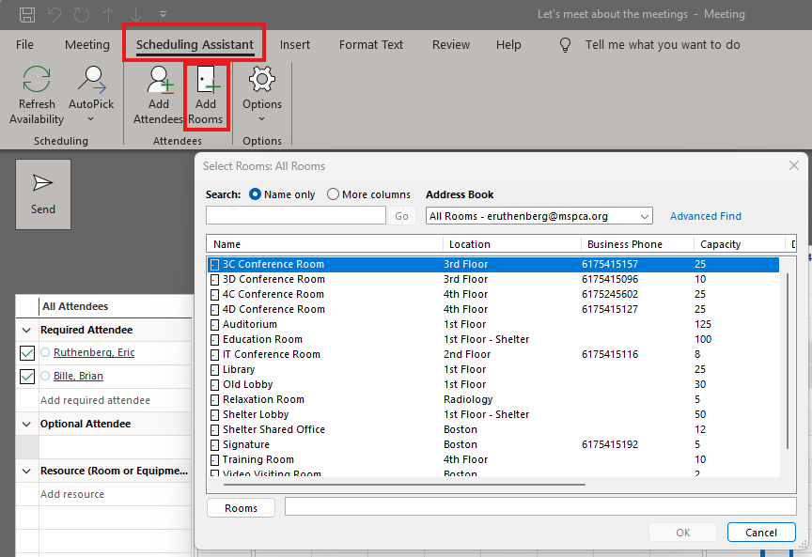

In the Scheduling Assistant window, you will see everyone’s availability, including the room you chose. If someone has something booked during the time you entered, use the “Auto Pick” button to ask Outlook to look for the next available time everyone is free, or simply click in the window where you see everyone is available.
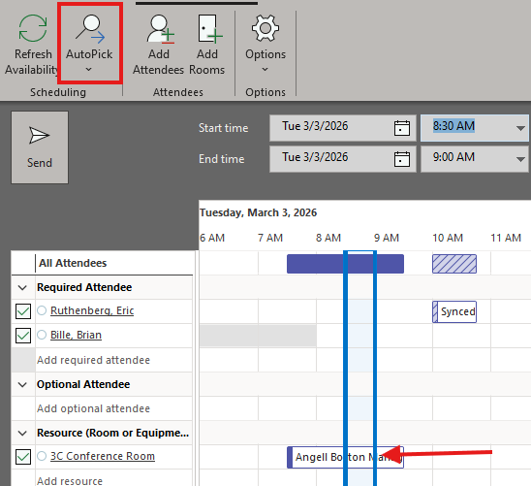
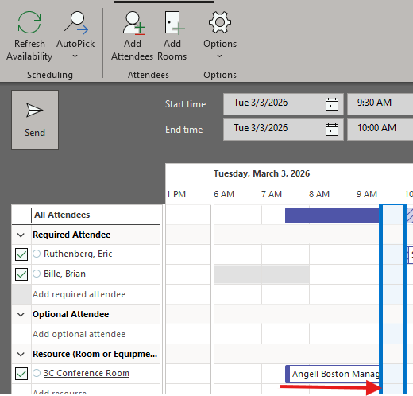

Lastly, type any message you wish to send in the body, and hit Send.
You will get a confirmation email from the room you booked if the room was available at that time. If the room was previously booked at that time, it will decline your invitation. Edit the meeting to choose a different room or a different time.

