How to Join a RingCentral Video Meeting in Your Web Browser

Click the link for the meeting, and enter your name on the landing page. Click JOIN MEETING NOW.

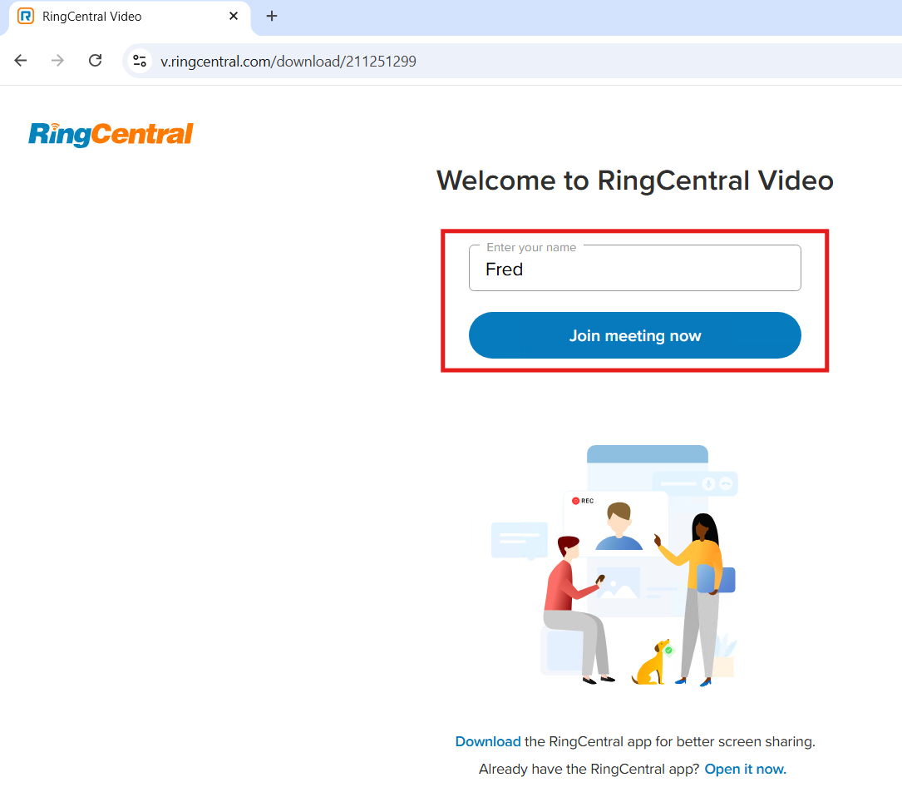

Click ALLOW WHILE VISITING THE SITE if prompted for permission to use your Camera or Microphone.
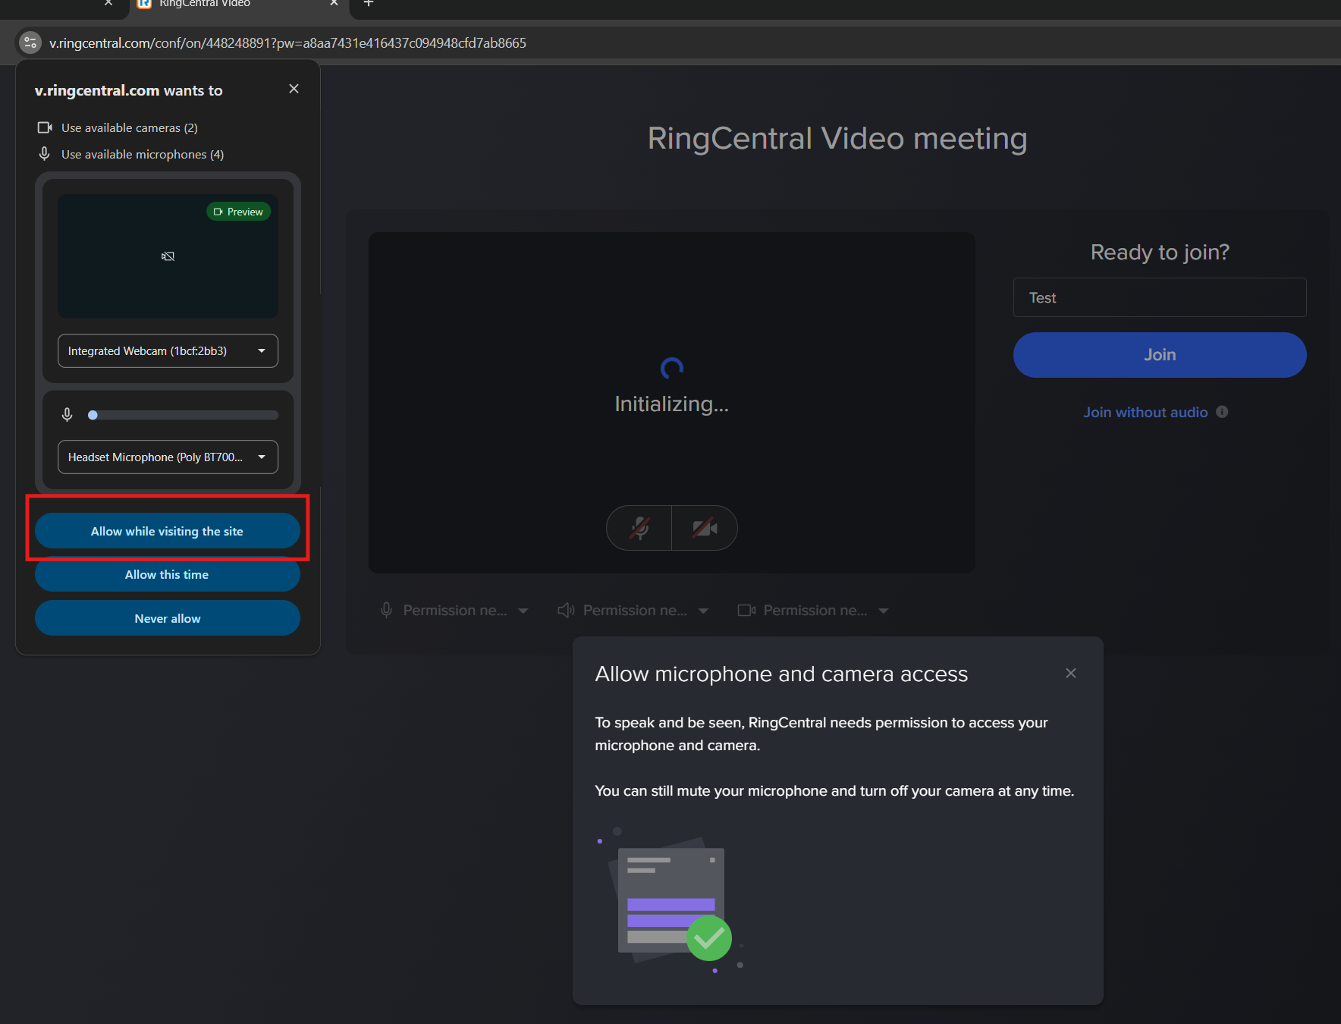
Make sure your mic, speakers and webcam are set to the correct device, and click JOIN
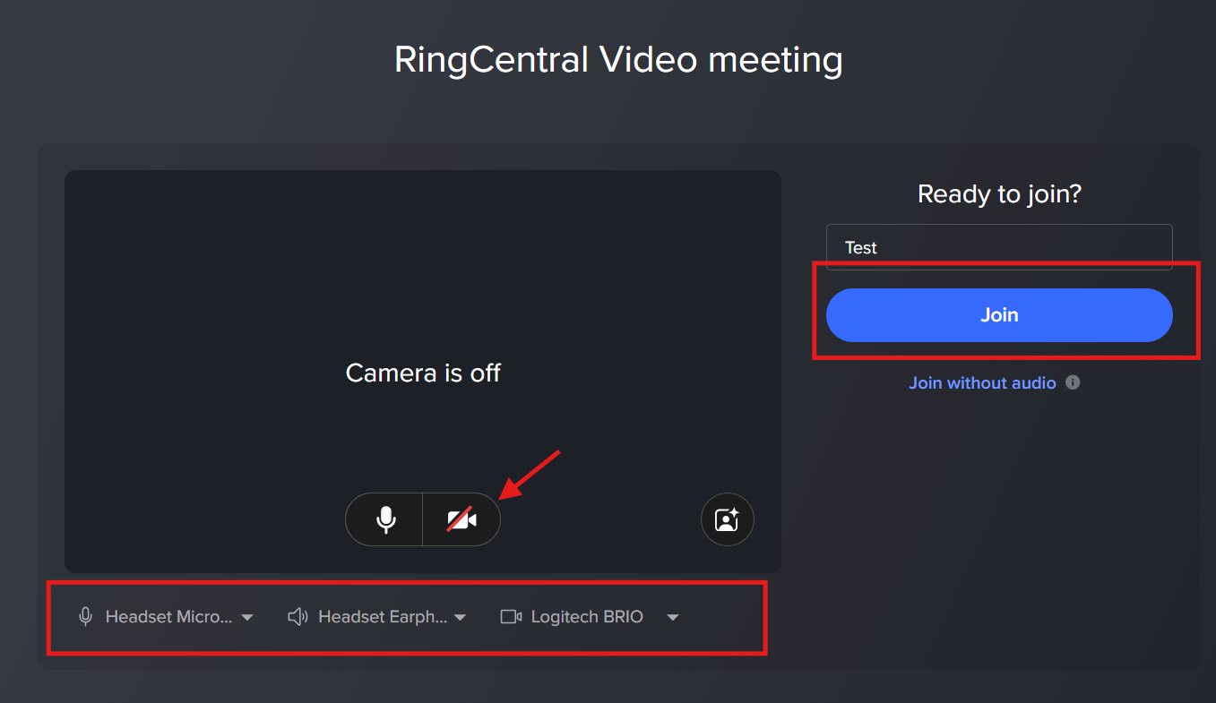

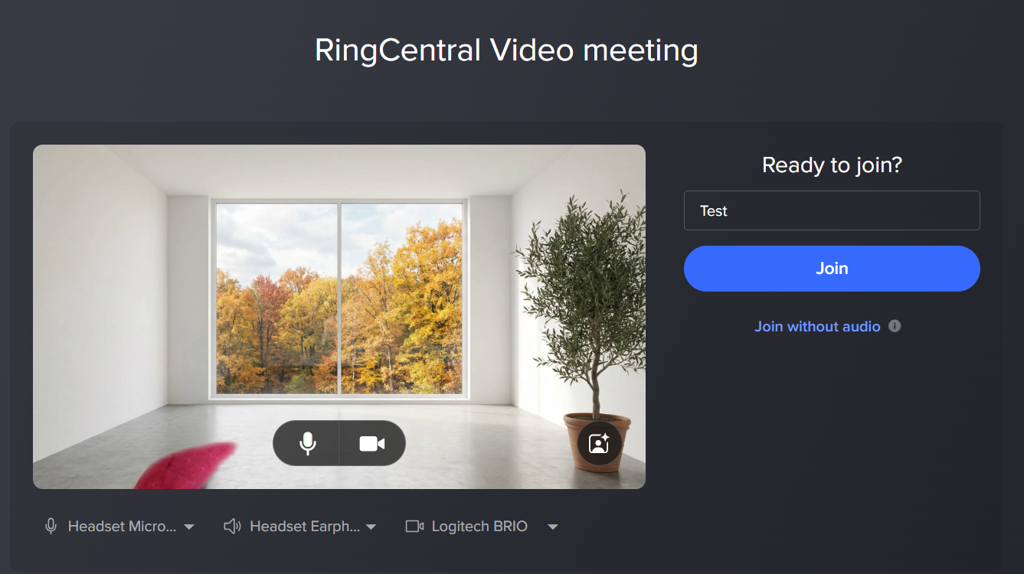

You will either be entered into the meeting automatically or the Host will admit you manually.

For more online help, see the article below:
https://support.ringcentral.com/article-v2/Joining-a-RingCentral-Video-meeting.html?brand=RingCentral&product=RingEX&language=en_US&pills-nav=web_browser

